Joint Embeddings Predictive Architecture (JEPA)
Motivation behind JEPA
In his 2022 paper on autonomous machine intelligence, Yann LeCun noted how ML systems fall short of animals and humans when it comes to exhibiting learning abilities and understandings of the world. Humans require relatively little experience to navigate unfamiliar situations and plan complex sequences of actions, whereas current systems often require large amounts of data and trial and error. He believed that the answer lies in the ability for living things to learn world models, which are internal models of how the world works. LeCun argued that intelligent machines need to acquire world models: internal models that represent the state of the world and predict how it may change.
The figure below from his paper illustrates this broader proposal. An encoder converts an observation into an internal state representation. An actor can use this representation to select an action while the world-model predictor estimates the representation of the next state resulting from that action. This enables an agent to anticipate the consequences of its behavior rather than finding out entirely through interactions with the real environment.
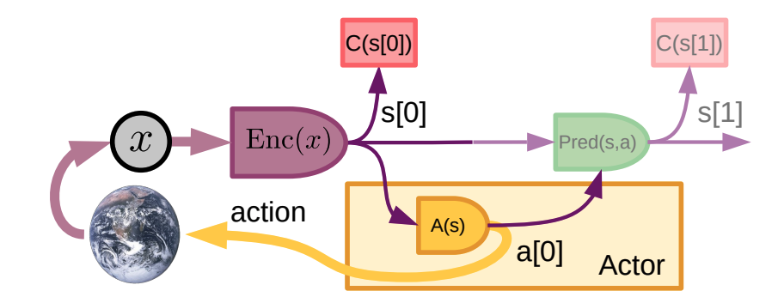
However, learning to predict the world directly in its raw form is difficult, especially when it’s through images or videos. Those contain enormous amounts of detail, much of which are irrelevant to do the task or are inherently unpredictable. Reconstruction methods must allocate capacity to predict these details, which can result in the model focusing on predicting useless details well and do poorly at guessing important details for the task. This severely limits the capabilities of world models that are based on reconstruction.
LeCun’s proposed solution was to perform prediction in an abstract representation space rather than directly in the original input space. Instead of the entire raw state, the model should predict an encoded representation containing the important and predictable properties. The JEPA was proposed as a framework for learning such representation and predictors.

What is JEPA
JEPA is a self-supervised learning framework in which a model learns to predict the representation of a target from the representation of related context (Usually temporal if predicting future state or “close” in reconstructing images). The context and target are generally two related signals. JEPA isn’t one fixed neural-network architecture, rather a general way of constructing and training predictive models.
The figure below compares JEPA with two related approaches to representation learning adapted from Assran et al. [2]
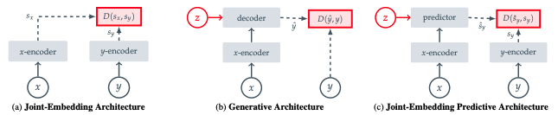
In a joint-embedding architecture, two related inputs x and y are separately encoded into representations. Training encourages the two representations to be compatible, usually by minimizing discrepancy. This learns which inputs should have similar representations but does not require a predictor to predict one representation from another. A generative architecture encodes x and passes its representation to a decoder to produce a reconstruction. The reconstructed output is compared with original target y. Prediction and evaluation occurs in the original input space.
JEPA combines both approaches. Context input x and target input y are both encoded and the predictor uses the encoded representation of x to predict encoded representation of y. Additional information z (also known as conditioning variable) is also passed into the predictor to specify the prediction. Think of it as “What do I need to know when given x so I can predict y”. For example, it can be action taken by an agent (Action + x will lead to y which is after action is taken) or positions of the region being predicted and positions x already revealed for images. The defining feature of JEPA is prediction occurs in the target encoder’s representation space.
A typical JEPA contains three main components:
- Context encoder that converts available context into a latent representation
- Target encoder that produces the representation that the model is expected to predict
- Predictor which estimates the target representation from the context representation and any relevant conditioning information
(Need talk about how training works and the loss function, particularly regularization loss tho only in challenges go into more details)

One of the earliest applications of JEPA is in 2023 when Image-based JEPA (or I-JEPA) is first introduced. It predicts the representation of several target image blocks from a single visible block. The dashed lines match each prediction with the corresponding target representation.
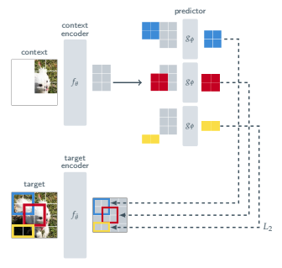
During training, an image is divided into patches. Several regions are selected as target blocks, as shown from the colored boxes. Patches that overlap with these target regions are removed from the input given to the context encoding, leaving a partial image intact. The context encoder processes the visible patches

Challenges and Limitations of JEPA
- Representation Collapse
- Good prediction targets
- Uncertain futures
- Long-horizon prediction
- Loss of task-relevant information
- Evaluation Difficulties

Applications of JEPA

Why is JEPA relevant to World Models

Author’s Note (Cuz I need give context beyond smthing that looks like an academic write-up)

Citations
[1] Yann LeCun, A Path Towards Autonomous Machine Intelligence (2022).

